**FROM STRENGTH TO STRENGTH: INCREASING ATT MEMBERSHIP IN THE ASIA PACIFIC**

Since its entry into force in December 2014, the Arms Trade Treaty (ATT) has been the only legally binding international agreement regulating the global arms trade. But in the Asia-Pacific 10 years on, attitudes towards the treaty vary greatly, despite relatively strict national laws on arms control and strengthening regional frameworks for cooperation and trade controls. Fifteen states in the Asia Pacific are states parties while eleven more are signatories. However, a further thirty have not yet joined the ATT. This is the highest figure of outstanding states for any region worldwide, and the driving necessity behind further universalization of the treaty.

On 21st February the United Nations Regional Center for Peace and Disarmament in Asia and the Pacific (UNRCPD), in cooperation with the Small Arms Survey (SAS), conducted a webinar titled “10 Years of the Arms Trade Treaty: Advancing universalization in the Asia Pacific.” The webinar reflected on the universalization of the ATT in the region a decade on from its entry into force, bringing together states representatives and civil society organizations, and was prescient in view of the ATT’s 11th Conference of States Parties (CSP11) Working Group on Treaty Universalization (WGTU) held the week after.

Following introductions and moderation from the UNRCPD’s Director, Mr. Deepayan Basu Ray, participants listened to opening remarks from the Head of the ATT Secretariat Ms. Carina Solmirano. Her remarks emphasized how despite the ATT’s membership to date more progress is needed in the Asia-Pacific. Many major arms exporters and recipients remain outside of the treaty, with many states still hesitant about joining due to fears or misconceptions surrounding the ATT. Ms Solmirano made clear that these barriers can be overcome by closer national cooperation in the arms control space and use of the ATT’s Voluntary Trust Fund (VTF) to address deficiencies in states existing frameworks and legislation. The region must be shown the benefits of the ATT in advancing their national security, upholding human rights, and enhancing international cooperation.

[Photo 1: Head of the ATT Secretariat Ms. Carina Solmirano delivers her opening remarks]

As the discussion continued, participants heard ATT experiences directly from involved states in the Asia-Pacific, including state parties such as the Republic of Korea (ROK) and the Philippines as well as signatories such as Cambodia. Mr. Kang Michael Kiseok, First Secretary of the ROK’s Permanent Mission to the UN in Geneva, gave a presentation highlighting the advantages of inter-agency cooperation ATT membership had brought, alongside advantages for the ROK’s domestic arms industry from enhanced export controls. Atty. Pierre Kalaw, Assistant Legal and International Affairs for the Office of the Special Envoy on Transnational Crime, Office of the President, the Philippines, emphased the strengths of the treaty’s international arms control cooperation and close synthesis with national development initiatives. Finally, Mr. Por Thao, Deputy Director of the Department of Planning within the General Department of Materials and Techniques, Cambodian Ministry of Defence, highlighted the tangible advances in combatting arms diversion to criminal and armed groups following Cambodia’s ATT membership, leading to increased foreign direct investment from enhanced stability. All three representatives also spoke of the actions needed to solve the ATT’s universalization challenges, including streamlined inter-agency cooperation, effective risk assessment criteria integrated into transfer and export/ import processes and enhanced public awareness.

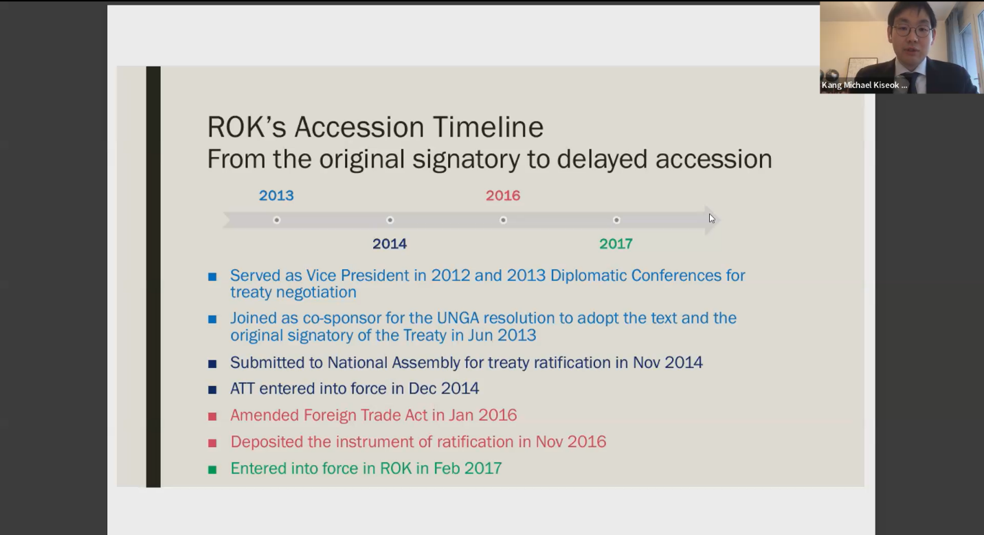

[Photo 2: Mr. Kang Michael Kiseok delivers his presentation on the ROK’s accession to the ATT]

Participants also received presentations from Civil Society Organizations (CSO’s) SAS and the Centre for Armed Violence Reduction (CAVR), highlighting the vital work of CSO’s in the adoption of the ATT and its wider universalization. SAS presented their critical work in the region supporting arms control, as well as the specific support given to ATT universalization and VTF initiatives. A key SAS project underway is the 2023-2025 analysis of Asia Pacific ATT universalization. The study has analyzed current challenges in ATT ratification and implementation in the region such as skepticism, lack of political motivation, limited financial resources and competing national priorities. This was then followed by CAVR’s own assessment of the ATT’s hurdles, returning to Ms. Solmirano’s theme of perceived challenges to national security and sovereignty. CAVR continues to support the ATT in the region through its assistance to states in reviewing laws and organizing policy dialogue, with awareness of national differences and histories. The prevailing consensus was that existing universalization problems can be overcome through greater international cooperation on legal reviews and reforms as well as the sharing of experiences, including the benefits from ATT membership by states parties.

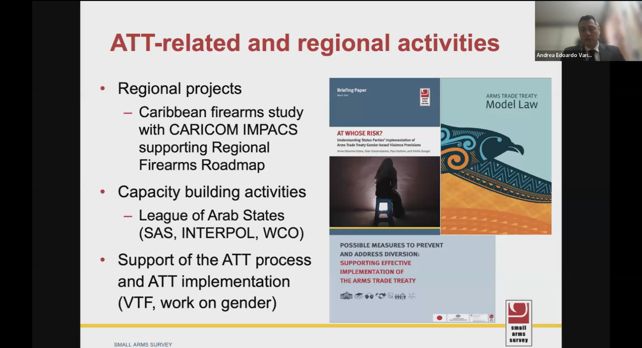

[Photo 3: Dr. Andrea Varisco of the Small Arms Survey describes the SAS’s work on the ATT]

[Photo 4: Mr. Alistair Gee from the Centre for Armed Violence Reduction shares recommendations for furthered ATT universalization]

The event concluded with video remarks from Ambassador Carlos Foradori, president of the ATT’s CSP11. In a world beset with armed conflict and the threats of non-state actors, the ATT is more prescient now than it has ever been. As Ambassador Foradori stated, universalization of the treaty is not merely an aspirational goal, but a necessity for the peace and security of the Asia Pacific.

[Photo 5: Ambassador Carlos Foradori delivers the webinar’s closing statement by pre-recorded remarks]

This webinar explored opportunities and challenges of universalization from the perspectives of government representatives and experts from the region. These perspectives were subsequently shared again during the ATT’s 11th Conference of States Parties (CSP11) Working Group meetings held during the week of 24 February 2025. During the Working Group on Treaty Universalization’s deliberations on 27 February 2025, UNRCPD delivered a presentation on the ways in which the ATT has been integrated into and across all the support and partnership mechanisms made available to member states in Asia-Pacific. The presentation looked at the ongoing partnership with the governments of Cambodia, Kyrgyzstan and Papua New Guinea on the UN Programme of Action on Small Arms and Light Weapons (UN PoA) and the Saving Lives Initiative (SALIENT). The key message shared was that even when the ATT is not the primary focus of such cooperation, the treaty is closely interwoven into analysis, policy pathways, and the underpinnings of inter-agency collaboration mechanisms. UNRCPD looks forward to supporting Asia Pacific member states to explore, and take comprehensive steps to join the ATT.